AI-Controlled Dosing System for pH and EC Regulation prompt
I want to develop a program in PyTorch that will control the dosing of pH and nutrient solutions in a hydroponic system with precision and intelligence.

System Parameters
The system will have the following input variables:
- Target Parameters:
  - Desired pH value (range: 5.5-6.5)
  - Desired EC value (range: 1.0-3.0 mS/cm)
- Physical Configuration:
  - Tank volume (liters)
  - Peristaltic pump activation times (milliseconds) for each pump
  - Circulation pump flow rate for mixing
  - MOSFET relay control pins for each peristaltic pump
- Solution Properties:
  - pH+ solution concentration (mol/L)
  - pH- solution concentration (mol/L)
  - EC+ solution concentration (mS/cm when undiluted)
  - Multiple nutrient solution options (Solution A and Solution B)

System Process Flow
- Event-Driven Analysis Cycle:
  - The ESP32 takes samples from the tank at its own frequency
  - Analyzes pH, EC, and other parameters
  - Sends measurement data to PyTorch program whenever new readings are available
  - The baseline properties (initial pH, EC) are automatically determined from first measurement
- Dosing Decision Point:
  - PyTorch model processes measurement data as soon as it's received
  - Calculates precise MOSFET activation durations based on empirical response data
  - Activates appropriate peristaltic pumps via MOSFET relays for calculated durations
- Empirical Learning Approach:
  - Start with minimum pump activation times (e.g., 500ms)
  - Observe actual pH/EC changes resulting from each dose
  - Gradually increase dosing times based on observed responses
  - Build empirical model of pump activation time vs. concentration change
  - Only use theoretical dilution equations when sufficient historical data exists
- Nutrient Solution Transition Detection:
  - Monitor EC depletion rates and patterns over time
  - Calculate and track nutrient consumption slopes
  - Automatically detect when plants are ready to transition from Solution A to Solution B
  - Trigger solution change when rapid EC drops are observed with stable pH (indicating accelerated metabolism)

System Architecture & Data Flow
- Component Integration:
  - Use a Python launcher script to start both dashboard and PyTorch controller
  - Dashboard handles all direct file I/O operations
  - PyTorch controller focuses on analysis and decision-making
- Inter-Process Communication:
  - PyTorch controller sends dosing decisions to dashboard via ZeroMQ or socket connection
  - Dashboard receives dosing commands and handles both:
    - Writing to CSV files
    - Sending commands to ESP32
  - This prevents file access conflicts and data corruption
- Startup Sequence:
  - Launcher script initializes both components
  - Dashboard establishes serial connection to ESP32
  - PyTorch controller connects to dashboard's command interface
  - System begins normal operation with coordinated data flow

Physical-Chemical Relationships
- pH relationship: pH = -log10[H+], with [H+][OH-] = 10^-14
- EC dilution follows: ECfinal = (ECsolution × Vsolution + ECwater × Vwater) ÷ (Vsolution + Vwater)
- Temperature compensation for both pH and EC measurements
- Depletion ratio = EC drop rate / time period (indicating plant consumption rate)
- Note: Theoretical equations serve as guidance only; system relies primarily on observed responses

Machine Learning Integration
- The PyTorch model should learn from:
  - Current error (difference between target and measured values)
  - Direct relationships between pump activation times and resulting concentration changes
  - Rate of change in measured values between sequential readings
  - System response to previous dosing actions
  - Tank volume impact on dosing requirements
  - Historical patterns in pH/EC drift
  - EC depletion rates and pattern changes indicating plant growth stages
- Model should predict:
  - Optimal pump activation time (milliseconds) for each adjustment needed
  - Expected system response after dosing
  - Confidence interval for the prediction
  - When to transition between nutrient solutions

Data Storage & Logging
- Record in existing dashboard CSV file:
  - Timestamp of each dosing action (using existing ESP32 timestamps)
  - Solution type used (pH+, pH-, or EC+)
  - Pump activation duration (milliseconds)
  - All dosing data added as new columns to the right of existing columns
  - No modification or removal of existing data/columns
- Calculate and store efficiency metrics (time to target, stability)
- Record EC depletion ratios and consumption slopes for growth stage analysis

Failsafe Mechanisms
- Implement upper limits on dosing quantities based on tank volume
- Use conservative incremental dosing until system response is well understood
- Verify sensor readings are within reasonable ranges
- Emergency stop if rapid, unexpected changes detected

Calibration & Learning
- Incorporate daily sensor calibration data
- Progressive refinement of dosing models with accumulating data
- Adaptation to changing conditions (seasonal water changes, etc.)
- Learn optimal timing for solution transitions based on historical data
- Continuously improve pump activation time vs. concentration change models

Future Scalability
- Modular design to incorporate new sensors (nitrate, phosphate, etc.)
- Framework for integrating interference correction between sensor readings
- API for external system integration
Algorithm prompt

Chemistry-Aware Adaptive Dosing System for Hydroponics

Problem Statement
The current hydroponics dosing system has a fundamental flaw - it operates without true chemical understanding. A proper science-based dosing system requires chemical principles, accurate calculations, and adaptive learning.

Key Variables
- pH_minus_molarity = 0.1M KOH solution
- pH_plus_molarity = 0.1M HCl solution
- EC_up_concentration = 200,000 ppm (mg/L)
- Pump Flow Rate = 50 ml/min
- Tank volume = 3L
- minimum_dosing_time = 25ms

Core Requirements

1. Solution Concentration Knowledge
- Store concentration values for pH up/down solutions in mol/L
- Store concentration values for nutrient solutions in ppm

2. Volume Calculations
- Pump time to volume conversion: Dosing Volume(mL) = flow_rate(mL/min) × time(ms) × (1/1000) × (1/60)
- Chemical dilution calculation: Dosing Volume(mL) = tank_volume(L) × 1000 × (concentration change / dosing solution concentration)

3. Chemistry Mathematics
- pH logarithmic calculations: pH = -log10([H+])
- Dilution formula: C₁V₁ = C₂V₂
- For pH: Calculate mmol of H+/OH- needed for desired pH shift

4. Adaptive Learning Approach
- Initial Phase (insufficient machine learning data):
  - Calculate theoretical dose volume
  - Apply 50% safety factor to avoid overshoot
  - Convert to pump time: pump_time_ms = (volume_ml / flow_rate_ml_per_sec) × 1000
- Learning Phase (after each dosing):
  - Measure actual parameter changes
  - Calculate effective flow rate: flow_rate = dosed_volume / observed_change
  - Update model with new correlation data
- Optimization Phase (for next dosing cycle):
  - Recalculate theoretical dosing using updated parameters
  - Incrementally adjust by adding minimum_dosing_time (25ms)
  - Verify against safety limits
This system starts with chemical first principles, then continuously optimizes based on observed behavior, creating a self-improving dosing solution that understands the actual chemistry of the hydroponic system.

Falta Comprar

Etapa | Objecto | Provedor | Link
Dosificacao | Solucao A | Leroy Merlin
Prototipagem | Aparafusador/brocas Madeira | Leroy Merlin
Mix | Bomba Aquario | Amazon/Temu | Feito
Mix | pH Salts | Amazon/Temu | Feito
NEXT STEP Prototype | PP | Aliexpress | Feito
NEXT STEP Prototype | pH sensor and PCB | Aliexpress
NEXT STEP Prototype | Nitrate cmbined sensor | Aliexpress
NEXT STEP Prototype | 3 way valves | Aliexpress | Feito
NEXT STEP Prototype | Regulador de tensao | Aliexpress/Temu | Feito

 |  | NPK (Mg-S) | Link | Preco
Hy-Pro Hydro | Solution A | 3-0-2
 | Solution B | 1-3-4
Plagron | Solution A | 3-0-1
 | Solution B | 1-3-6
FloraDuo | Solution A | 5-0-6  (1 - 0 - 1.2)
 | Solution B | 1-5-4
Adubo para horta SIRO PROTEAS LIBERT 120GR |  | 16-0-10  (1.5 - 0 - 1) | Link | 2 euros
Adubo granulado universal Siro Libert 120gr |  | 18-6-8 (4-9)  (3 - 1 - 1.3) | Link | 2 euros
Adubo granulado fltoração Siro Libert 120gr |  | 13-13-13 (3-8)  (1 - 1 – 1) | Link | 2 euros
Adubo granulado orquídeas Siro 120gr |  | 16-6-12 (2-4)  (2.6 - 1 – 2) | Link | 2 euros
Adubo húmus horta SIRO 1lt | 1 tampa para 5L água | 3-0-3 | Link | 6euros/L

Novidades
V1

V2 (02-02-2024)
Actuators - everything ok

V3 (03-02-2024)
Actuators - everything ok

pH sensors connected
EC sensors connected
Temperature sensor - x
PrgCal V4 - V
Dashboard V4 - V
Nitrate sensor ( Temperature ) – estranho

V4 (11-03-2024)

Implementacao de Calibracao pH sensor ( Scenario 1, Scenario 2, Scenario 3)
Definição de pH values Calibration no cvs (PRG Cal)( pHexcepted Value)
Measure (0,1) (read, dont read)
pHexpected Value (-1,>0) ( dont read, pH calibration Value)

V4p2 (11-03-2024)

X e Y de PRGCal e PRGSample, apenas 1 vez

V4p3 (13-03-2024)

X e Y de PRGCal e PRGSample, repete
Dashboard terminal output optimized
V3 to waist connected to GPIO18, and PGRCal and PRGSample updated

V6

ADS1115s ( 16 bit)
Filter Comparison

Project Components and Variables Checklist
V4p5 (14-03-2024)

 | Event  (x PRGcal + y PRGSample) | Voltage | Calibration | Interpolation (Value)
Actuator | V | - | - | -
Photodiode | V
ECsensor | V | V | X | X
pHSensor | V | V | V | X
Nitrate Sensor |  | V | X | X
Events (x and Y) | V
Log | V | V | V
Graph | V | V | V
Data.cvs | V | V | V

Project Components and Variables Checklist
V4p6 (14-03-2024)
 | Event  (x PRGcal + y PRGSample) | Voltage | Calibration | Interpolation (Value)
Actuator | V | - | - | -
Photodiode | V | - | - | -
ECsensor | V | V | X | X
pHSensor | V | V | V | V
Nitrate Sensor | V | V | X | X
Events (x and Y) | V | V | V | V
Log | V | V | V | V
Graph | V | V | V | V
Data.cvs | V | V | V | V

Project Components and Variables Checklist
V4p8 (14-03-2024)
 | Event  (x PRGcal + y PRGSample) | Voltage | Calibration | Interpolation (Value)
Actuator | V | - | - | -
Photodiode | V | - | - | -
ECsensor | V | V | X | X
pHSensor | V | V | V | V
Nitrate Sensor | V | V | X | X
Events (x and Y) | V | V | V | V
Log | V | V | V | V
Graph | V | V | V | V
Data.cvs | V | V | V | V

V4p9 (14-03-2024)
Hydrodynamic conditions (PRGx 4p7 and PRGx 4p8)
pH meter with 12 bit ADC
Wait (s) | Potentiometer 1  (Close to BCN connector) | Potentiometer 2 | RSD | (VpH) | Range
110 | Min | Max | 4.8 | 6 ± 0.29 | 5.7-6.3
110 | Min | Min | 4.2 | 6 ± 0.25 | 5.7-6.3
220 | Min | Min | 6.2 | 6 ± 0.37 | 5.6-6.4
vvsd
V6
Filter Comparison

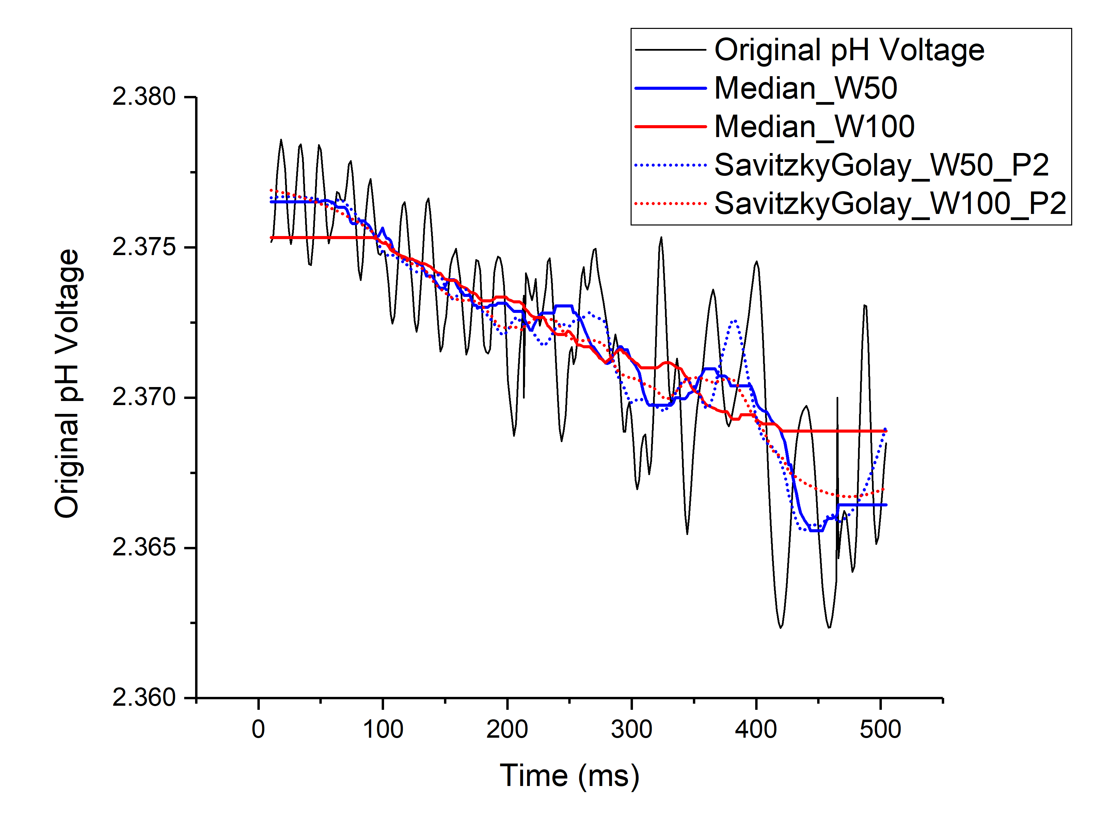

Filter | Window Size | Std Deviation | pH error
Median | 50 | 0.00226142 | 0.015
Median | 100 | 0.00248251 | 0.015
Savitzky Golay P2 | 50 | 0.00221321 | 0.015
Savitzky Golay P2 | 100 | 0.00218033 | 0.015

Reproducibility
Filter | Waiting Time | pHvoltage  RSD (%) | pH value RSD | Sample time
Median  60 points | 500 | 0.09 |  | 10 min
Median  60 points | 250 | 0.17
Median  60 points | 300 |  |  | 5 min
Median  60 points | 125 | 0.41
Median  60 points | 50 | 1.34 |  | 2.5 min

Filter | Waiting Time | Dependency
Injection time | 30 | Fluidics
Air Injection Time | 10 | Fluidics
Wait time |  | Sensors and Filter
Measure time | 1 | ESP32
Cleaning time | 59 | Fluidics

ADC | Error pH value | Increase of bits compared to previous
12bits | 2.1 | Fluidics
16bit | 0.2 | 33 %
24bits | 0.01 ? | 50 %

Soluções

Recommended NaOH Concentrations for pH Adjustments
- 0.1 M NaOH:
Suitable for controlled pH adjustments in most cases.
- 0.01 M NaOH:
Best for fine-tuning, minimizing overshooting.
- 1 M NaOH:
Too strong; difficult to control small pH changes.

Preparation of NaOH Solutions

To Prepare a 0.1 M NaOH Solution:
- Weigh 4 grams of NaOH pellets.
- Dissolve the pellets in 1 liter of distilled water.

Preparation of a 0.1 M HCl Solution from Muriatic Acid

Desired Concentration and Final Volume:
- Desired concentration: 0.1 mol/L (0.1 M)
- Final volume of solution: 500 mL (0.5 L)

Calculations:
- Determine the Number of Moles Needed
  - Formula:
n (mol) = Concentration (mol/L) × Volume (L)
  - Calculation:
n = 0.1 mol/L × 0.5 L = 0.05 mol of HCl
- Calculate the Volume of Commercial Muriatic Acid Needed
  - Commercial muriatic acid (hydrochloric acid) is typically about 37% by mass, which is approximately 12 M (mol/L).
  - Formula:
Volume (L) = n (mol) ÷ Concentration (mol/L)
  - Calculation:
Volume = 0.05 mol ÷ 12 mol/L = 0.00417 L (or 4.17 mL)

Conclusion
To prepare 500 mL of each solution, use the following summary:
- 0.1 M NaOH: Weigh 2 grams of NaOH pellets and dissolve in 500 mL of distilled water.
- 0.1 M HCl from Muriatic Acid: Measure 4.17 mL of muriatic acid and dilute 500 mL of distilled water.

To do

ESP32
Tarefa | State | Finish
Enviar tempo
Media
bitwise operations (events.h)

Temperatura
Gravar dados para um ficheiro |  | Melhorar
PRGCal
PRGSample
REF |  | Verificar
Measure |  | Verificar com PH sensor!
RCal |  | Verificar com PH sensor!
Interpolation |  | Verificar com PH sensor!
Real time - delay de 8 s |  | Verificar
Separar tudo em ficheiros
Calibrar sensor EC |  | Comprar referencia
Calibrar pH |  | Comprar Referencia
pH up |  | NaOH/KOH
pH down |  | Nitric acid/Phosphoric acid
Calibrar ISE nitrato |  | KNO3

To create a program where you assign a bit value for the state of each actuator and then program a sequence of events, you can use bitwise operations to manage the states of the actuators. Each bit in a byte (or larger data type) can represent the state of a specific actuator. You can then create an array of these bytes to represent the sequence of events.

ESP32 Code : VSCODE: main.cpp
Initialize ESP32 to UART VSCODE: View-> Command Pallete->Serial Monitor
platformio device monitor --baud 115200

Initialize Dashboard TERMINAL: cd ~/Desktop
python3 dashboardv3.py

Initialize Dashboard view CHROME: http://127.0.0.1:8050/

Action | Terminal | Code
ESP32 Code | VSCODE | main.cpp
Initialize ESP32 to UART | VSCODE | View-> Command Pallete->Serial Monitor
 | Mac | platformio device monitor --baud 115200
Initialize Dashboard | Mac | python3 "/Users/penutaco/My Drive/Teste LEDs/0 Dasboard/dashboardv3.py"
 |  | python3 dashboardv3.py
Initialize Dashboard view | CHROME: | http://127.0.0.1:8050/

Ser a ordem de iniciacao….talvez seja preciso começar pelo gráfico e depois o platformio

Program Events (Bitwise Operation)

Action | Terminal | Code
 | MAC | python3 "/Users/penutaco/My Drive/Teste LEDs/1 PRG Events protocol/2 GenerateEvents.py"

Experimental Section:

1. pH value repetitively variation for potentiometer setting and waiting time

SW version: 4p9 Teste LEDs V4p9 (17 03 2025)
pH sensor: 12bit Ads
Event files: PRGcal V4p7p1 and V4p8
PRGsample V4p7p1 and V4p8

Reagents

 | pH Value  (Potentiometer 1 minimum, Potentiometer 2 maximum,  110 s wait) | pH Value  (Potentiometer 1 minimum, Potentiometer 2 minimum,  , 110s wait time) | pH Value  (Potentiometer 1 minimum, Potentiometer 2 minimum,  , 220s wait time)
pH | 6.93 | 6.87 | 7.56
Error | 0.57 | 0.48 | 0.64
Standard Deviation | 0.335 | 0.288 | 0.466
RSD | 4.83 | 4.18 | 6.16

2. pH value repetitively for ADC 12V vs 16V

SW version: 4p9 Teste LEDs V4p9 (17 03 2025)
pH sensor: pH sensor: 12bit Ads (Potentiometer1: minimum, Potentiometer 2: minimum)

Event files: PRGcal V4p7p2
PRGsample V4p7p2

Calibration Reagents pH 4.01 Salt (new)
pH 6.89 Salt (new)
Sampling reagents pH 6.89 Salt (new)

